1. **Which are the top three variables in your model which contribute most towards the probability of a lead getting converted?**

**Ans-**

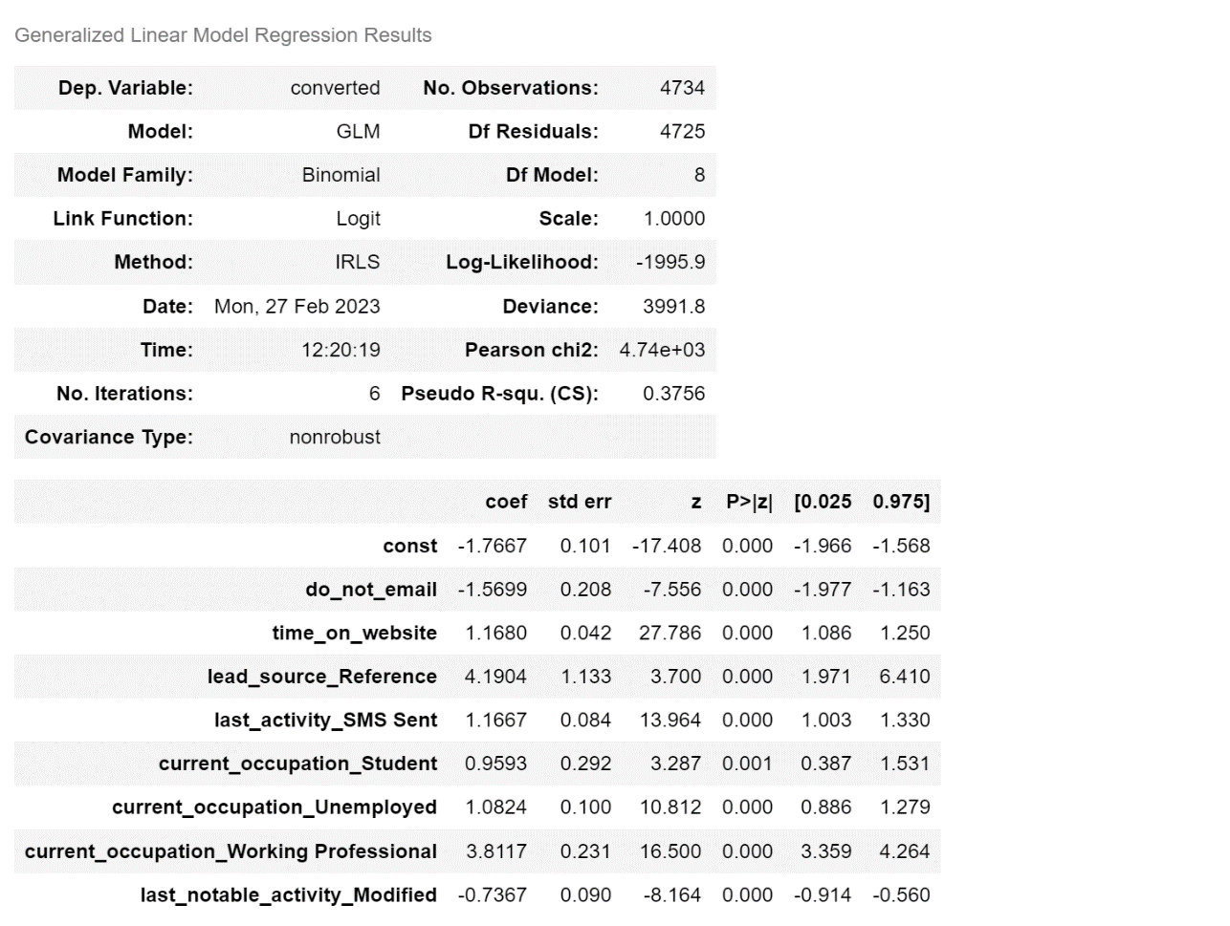

*Fig: Summary of the final Model*

The top three variables which contributed most positively towards the probability of a lead getting converted in order are:

1. lead_source_Reference – Coeff. 4.19
2. current_occupation_Working Professional - Coeff. 3.81
3. time_on_website (*originally- total_time_spent_on_website*)- Coeff. 1.16
4. **What are the top 3 categorical/dummy variables in the model which should be focused the most on in order to increase the probability of lead conversion?**

**Ans-**

The top 3 categorical/dummy variables in the model which should be focused the most on in order to increase the probability of lead conversion are –

1. lead_source_Reference – Coeff. 4.19
2. current_occupation_Working Professional - Coeff. 3.81
3. last_activity_SMS Sent – Coeff. 1.16
4. **X Education has a period of 2 months every year during which they hire some interns. The sales team, in particular, has around 10 interns allotted to them. So, during this phase, they wish to make the lead conversion more aggressive. So, they want almost all of the potential leads (i.e., the customers who have been predicted as 1 by the model) to be converted and hence, want to make phone calls to as much of such people as possible. Suggest a good strategy they should employ at this stage.**

**Ans-**

As a final result of the model, we have given Lead Score to the leads from 0 to 100. For this score we have chosen 0.38 as the threshold value, means we have assigned 1(i.e., Converted) to the leads whose probability is above 0.38 and got the accuracy of approx. 80%.

Below are the points based on the final logistic regression model we have got which team can follow to maximize the Lead Conversion:

* **Prioritize Leads:** Prioritize leads that have been predicted as 1 by the logistic regression model. They can sort the leads based on their scores and start making calls to the leads with the highest scores. In this way, conversion will be higher.
* **Try contacting referral leads first:** As depicted by the model on top priority, try to contact leads that are coming through reference of already enrolled students or alumni, as they have already briefed them about the courses and platform, the chances to convert them increase as they already have the trust of someone known who have taken the course.
* **Try on contact Working Professionals:** As model is showing, working professionals are interested in courses and their conversion % is also high compared to others. So, while prioritizing leads, set working professional as filter and try to contact them first.
* **Focus on SMS:** As depicted by the model that consumers who have converted previously, last activity performed on them is sending of message. Try to circulate SMS through auto system and then contact via call, because generally people ignore the emails but as SMS are shorter and as notification pops up they read it.
* **Create a script:** Company should create a script for their sales team to follow when making calls. The script should include key talking points and objections that the sales team is likely to encounter.
* **Personalize the calls:** Company should personalize their calls as much as possible. They should use the lead's name, company name, and any other relevant information they have about the lead.
* **Free trials:** As the company has a team of 10 more people in group they can divide the team in half, one part can focus on conversion through calls can convince the customer to take a demo and once convinced, other team can give them a walkover of website, how their platform works and can free trial of some live classes because the model is also depicting that “time_spent_on_website” has higher chances of conversion.
* 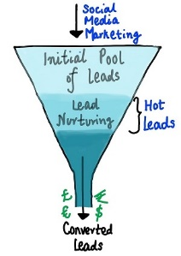**Special Offer:** As company is focusing on hot leads, can we also provide some discount or special offer in case consumer purchase the course within those 2 months.
* **Follow Up:** This is the more important step to follow, i.e., Follow Up, as discussed in the problem statement as well, in the middle stage, you need to **nurture the potential leads** **well** (i.e., educating the leads about the product, constantly communicating etc.) in order to get a higher lead conversion.

1. **Similarly, at times, the company reaches its target for a quarter before the deadline. During this time, the company wants the sales team to focus on some new work as well. So, during this time, the company’s aim is to not make phone calls unless it’s extremely necessary, i.e., they want to minimize the rate of useless phone calls. Suggest a strategy they should employ at this stage.**

**Ans-**

Now, in this condition, as the target is already achieved company can follow following points to reduce the time consumption of sales team in conversion:

* **Prioritize Leads based on referrals:** First prioritize leads on lead score and then focus on referral leads, as, referral leads are easy to convert, will require lesser calls to make.
* **Automate lead nurturing:** The company can set up an automated lead nurturing system that sends out targeted emails and messages to the prioritize leads. This will keep the leads engaged and interested in the courses without requiring the sales team to make phone calls.
* **Offer personalized content:** Based on the data collected on the leads, the company can offer personalized content such as blog posts, videos, and webinars that will be of interest to the leads. This will keep the leads engaged and increase the chances of conversion.
* **Automated Content Creation:** As depicted by the model, time spent on website have higher chances of conversion, therefore try to increase the online content on social media and other website so that leads directly approaches website and spend some time to explore their courses. Also make sure website has a good interface.